

### Tripadvisor E-Management

### Project Overview

The TripAdvisor E-Management project is designed to create a comprehensive management solution to streamline various travel-related services on the Salesforce platform. This application empowers users to manage data related to hotels, food options, flights, and customer information. The project aims to support TripAdvisor’s business by providing a single platform that enhances operational efficiency, automates processes, and improves the user experience for customers planning their trips.

The application combines data management, automation, and email alert functionalities to enhance user interactions and help customers make informed decisions based on reviews, insights, and services available in real-time. By leveraging Salesforce’s automation features, the system reduces manual workload and ensures accuracy across different modules.

The TripAdvisor E-Management System project integrates the TripAdvisor platform with Salesforce to streamline travel management by centralizing data and automating processes for hotels, flights, and food options. The primary objective is to create an all-in-one travel companion that simplifies planning, booking, and managing trips. The Salesforce-driven solution is aimed at enhancing the user experience through automated updates, customer discounts, and scheduling reminders. By leveraging custom objects, workflows, and scheduled Apex jobs, this project optimizes operations and ensures a seamless travel experience for customers.

**Project Goals:**

* **Enhance User Experience:**

Provide seamless interaction for users managing bookings, reviews, and travel plans through a user-friendly interface.

* **Increase Customer Engagement:**

Foster customer interaction through personalized recommendations, offers, and updates based on their preferences and past behavior.

* **Scalability and Integration:**

Build a flexible system that can easily scale as TripAdvisor expands and integrates with other tools and platforms.

* **Ensure Security and Compliance:**

Implement strong security measures to protect user data and comply with relevant regulations such as GDPR.

* **Optimize Operations:**

Streamline internal processes such as booking management, customer service, and feedback collection using automated tools and integrated workflows.

### Objectives

**Business Goals:**

1. **Increase Market Share and Customer Acquisition:**

Expand TripAdvisor's presence in the digital travel management space, attracting new users and expanding its user base.

1. **Maximize Revenue through Effective Monetization:**

Generate additional revenue streams through premium features, partnerships, and targeted ads.

1. **Boost Brand Loyalty and Customer Lifetime Value:**

Build a strong, loyal customer base by creating an intuitive, reliable platform that users trust for all travel needs.

1. **Optimize Operational Efficiency for Cost Savings:**

Automate processes and minimize manual intervention to reduce operational costs, improving profitability.

1. **Enhance Data Utilization for Informed Decision-Making:**

Leverage user and travel data to make strategic decisions, drive product improvements, and capitalize on emerging market trends.

**Specific Outcomes:**

1. **Growth in Market Penetration:**

Achieve a 30% increase in app downloads and new user registrations within the first 12 months. Expand the app's market share in the digital travel management sector by 15%.

1. **Increased Revenue Generation**:

Raise ad revenue by 25% through targeted advertising and sponsored listings. Introduce premium subscription options, aiming for a 10% adoption rate among active users within the first year.

1. **Enhanced Customer Retention and Lifetime Value:**

Improve customer retention rates by 20% by implementing loyalty programs and providing exclusive offers. Increase customer lifetime value (CLV) by 15% through personalized recommendations and repeat user incentives.

1. **Reduction in Operational Costs:**

Cut down processing and customer support costs by 35% with automation and self-service options. Decrease average handling time for bookings and inquiries by 50% through streamlined workflows.

1. **Data-Driven Product Enhancements and Business Growth:**

Generate insights that lead to the development of at least two new app features annually based on user data and feedback. Improve marketing campaign effectiveness by 20% through data-driven targeting and segmentation.

### Salesforce Key Features and Concepts Utilized

The TripAdvisor E-Management platform can leverage several key features and concepts within Salesforce to enhance customer experiences, streamline operations, and drive business growth.

**Custom Objects and Fields:**

* Separate objects for hotels, food options, customers, and flights, with custom fields to track essential details.

**Flow Automation:**

* Flows are used for discount calculations based on customer spending thresholds.

**Apex Triggers and Handlers:**

* Triggers ensure hotels are updated with new or modified food options.

**Scheduled Apex Class:**

* Scheduled job for flight reminders 24 hours before departure.

**Email Notifications:**

* Automated email reminders for customers about flight schedules.

1. **Detailed Steps to Solution Design**

This section outlines the detailed steps taken to design a solution that meets the project requirements.

### Setting Up the Salesforce Developer Account

Created a Salesforce Developer Account to access the development tools necessary for building and testing the application. This provided a controlled environment for implementing and refining features.

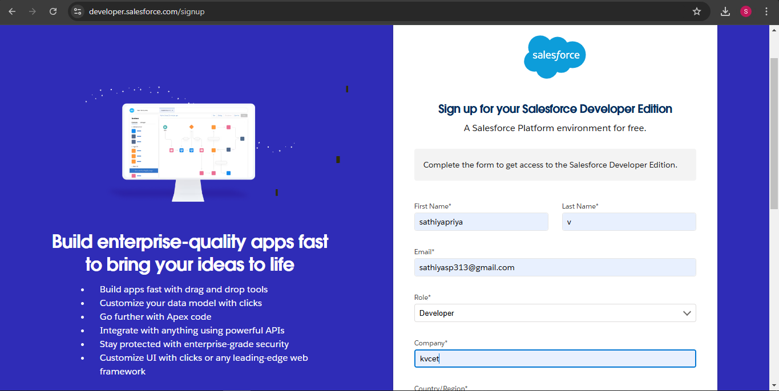

Creating Developer Account

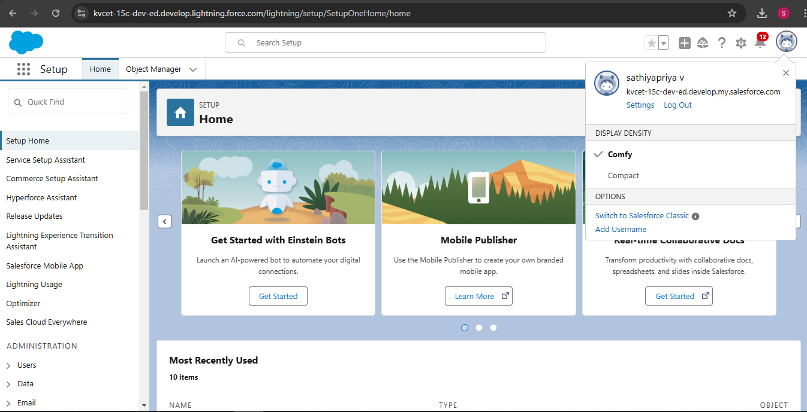

Account Activation

### 

### Defining Custom Objects:

**Hotel Object**:

* **Fields**: Hotal Name (Text), Total Food Options (Number).
* **Purpose**: To store information about hotels and track the availability of meal options.

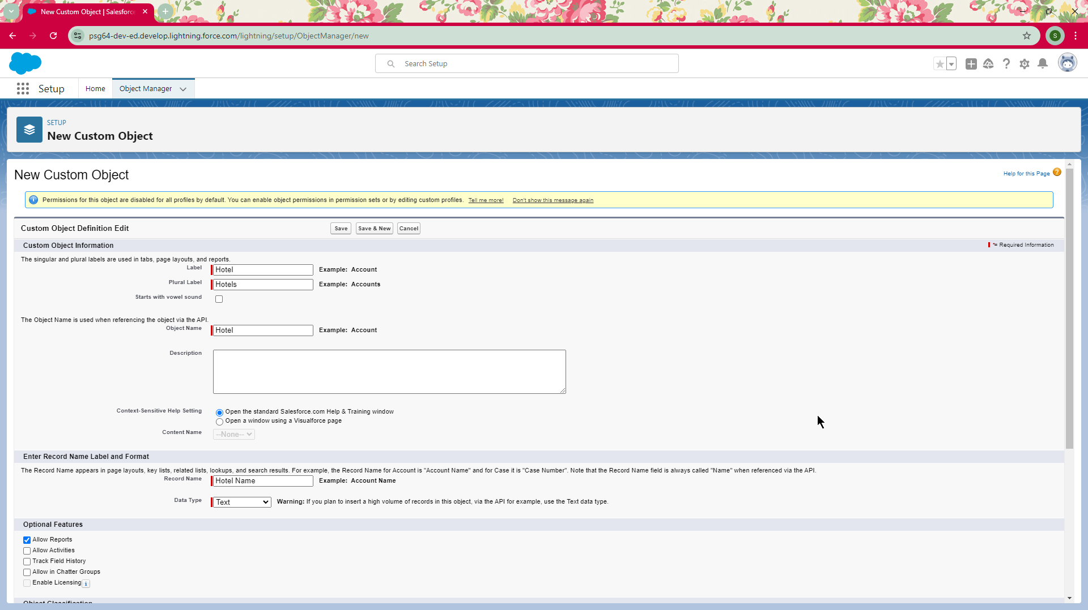

Creating object Hotel

**Food Option Object**:

* **Fields**: Name (Text), Hotel (Lookup), Food Amount (Currency).
* **Purpose**: To Catalogue food offerings associated with hotels.

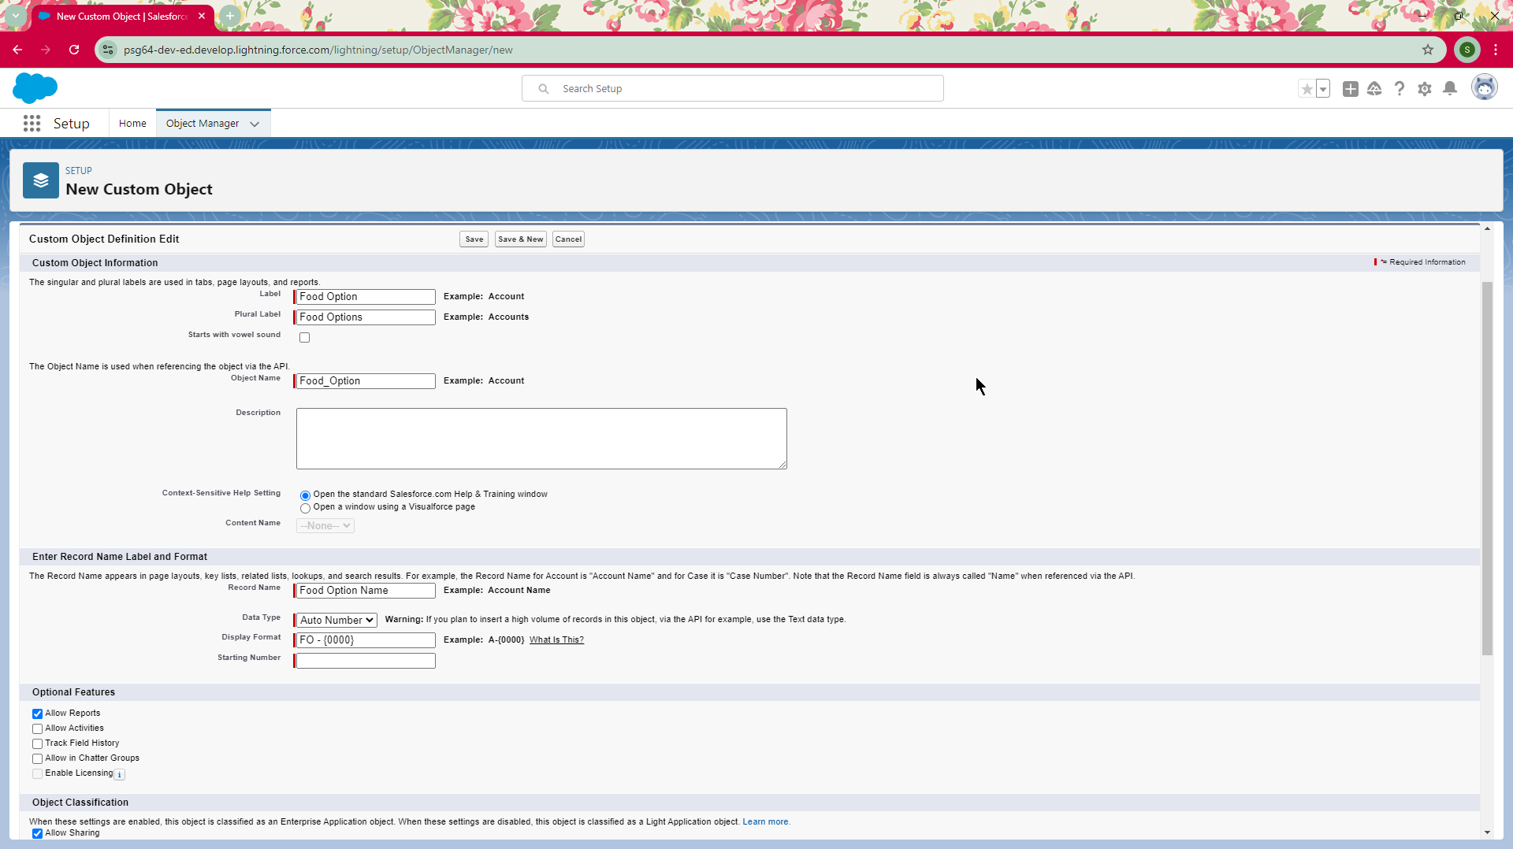

Creating object Food Option

**Flight Object**:

* **Fields**: DepartureDateTime (Date/Time), ContactEmail (Text).
* **Purpose**: To manage flight schedules and send reminders.

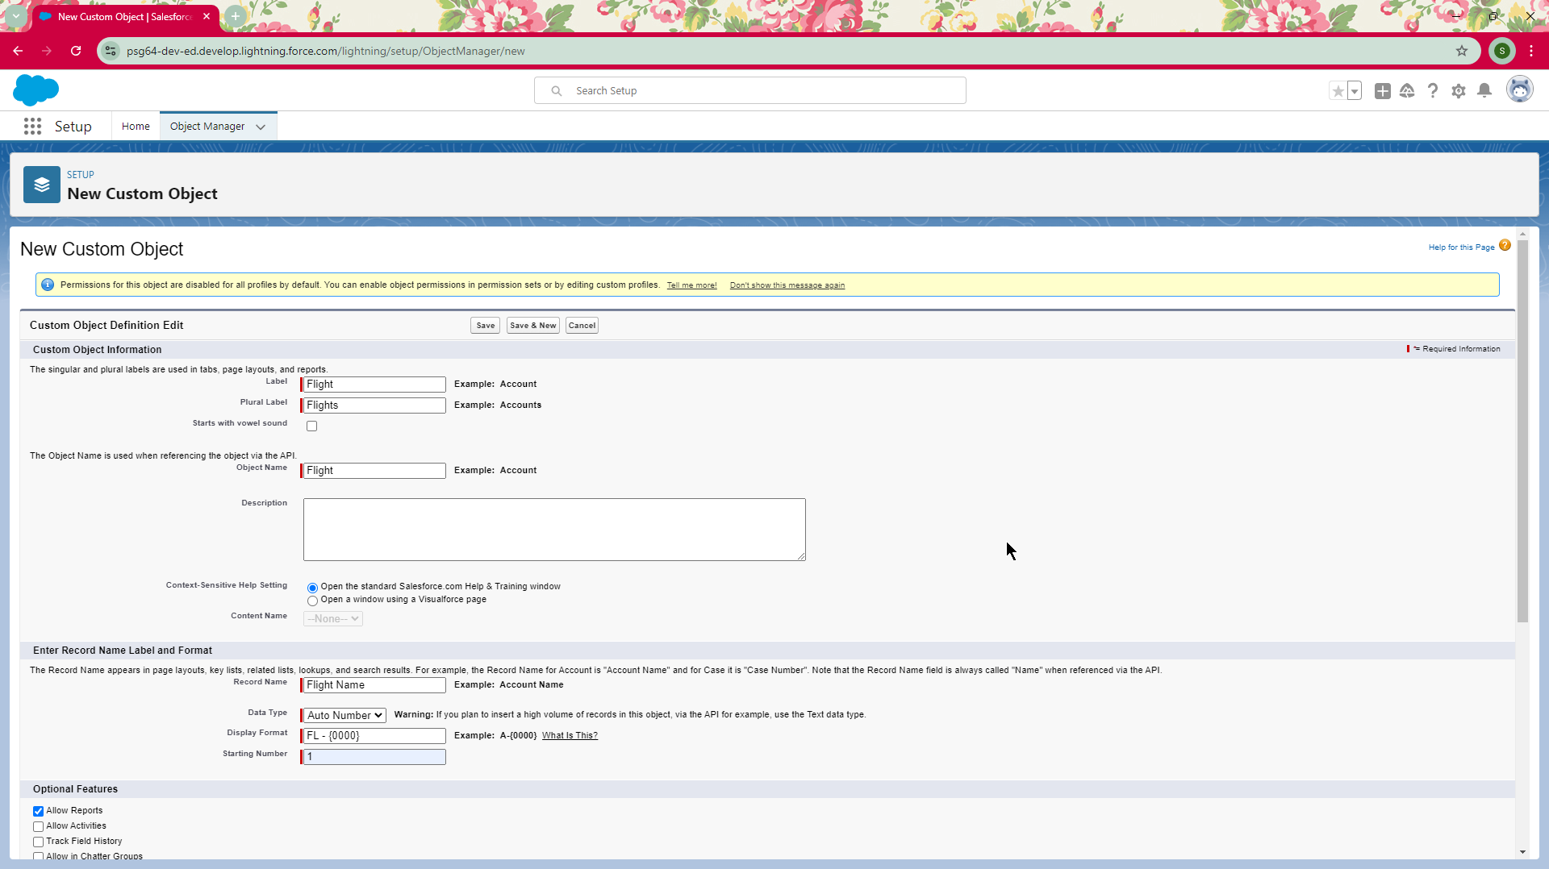

Creating object Flight

**Customer Object**:

* **Fields**: Name (Text), Total Spending (Currency), Discount(Percentage).
* **Purpose**: To track customer interactions and calculate eligible discounts.

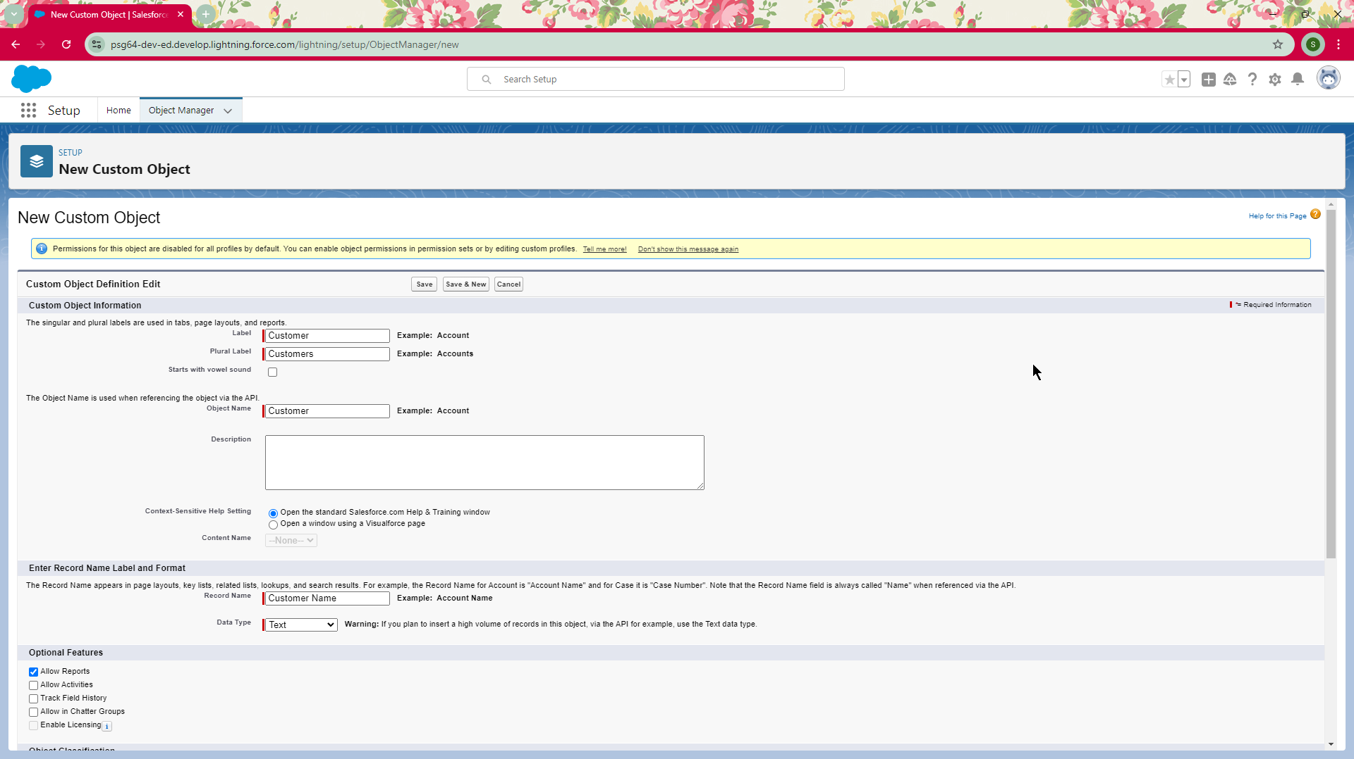

Creating object Customer

#### Field Definitions

**Hotel Object Fields**:

* + **TotalFoodOptions** (Number): Tracks the total number of food options available at each hotel.
  + **Date** (Date): The date of hotel information entry or update.

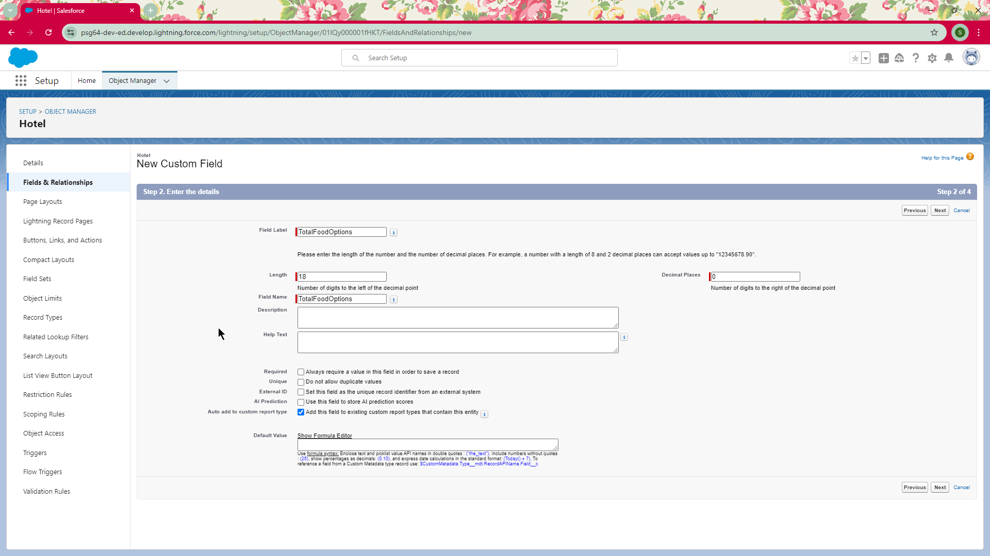

Creating field TotalFoodOptions

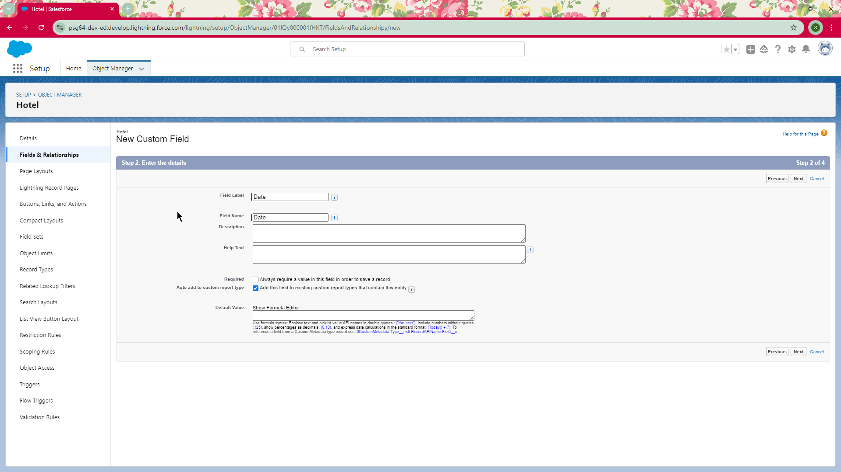

Creating field Date

**Food Option Fields:**

* **Name (Text):** The name of the food option.
* **Hotel (Lookup):** A lookup field linking each food option to the respective hotel.
* **Food Amount (Currency):** The price of the food option.

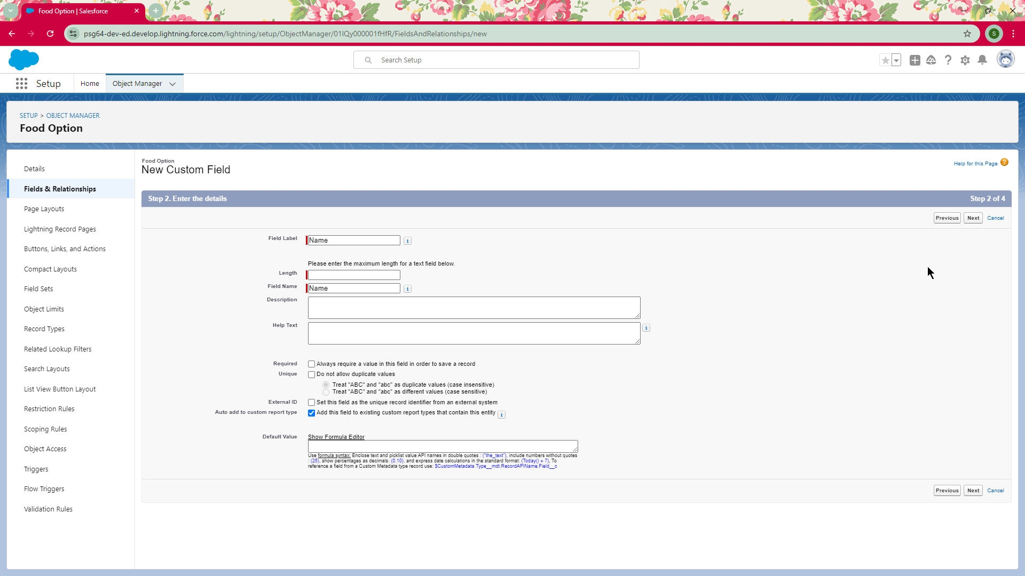

**Creating field Name**

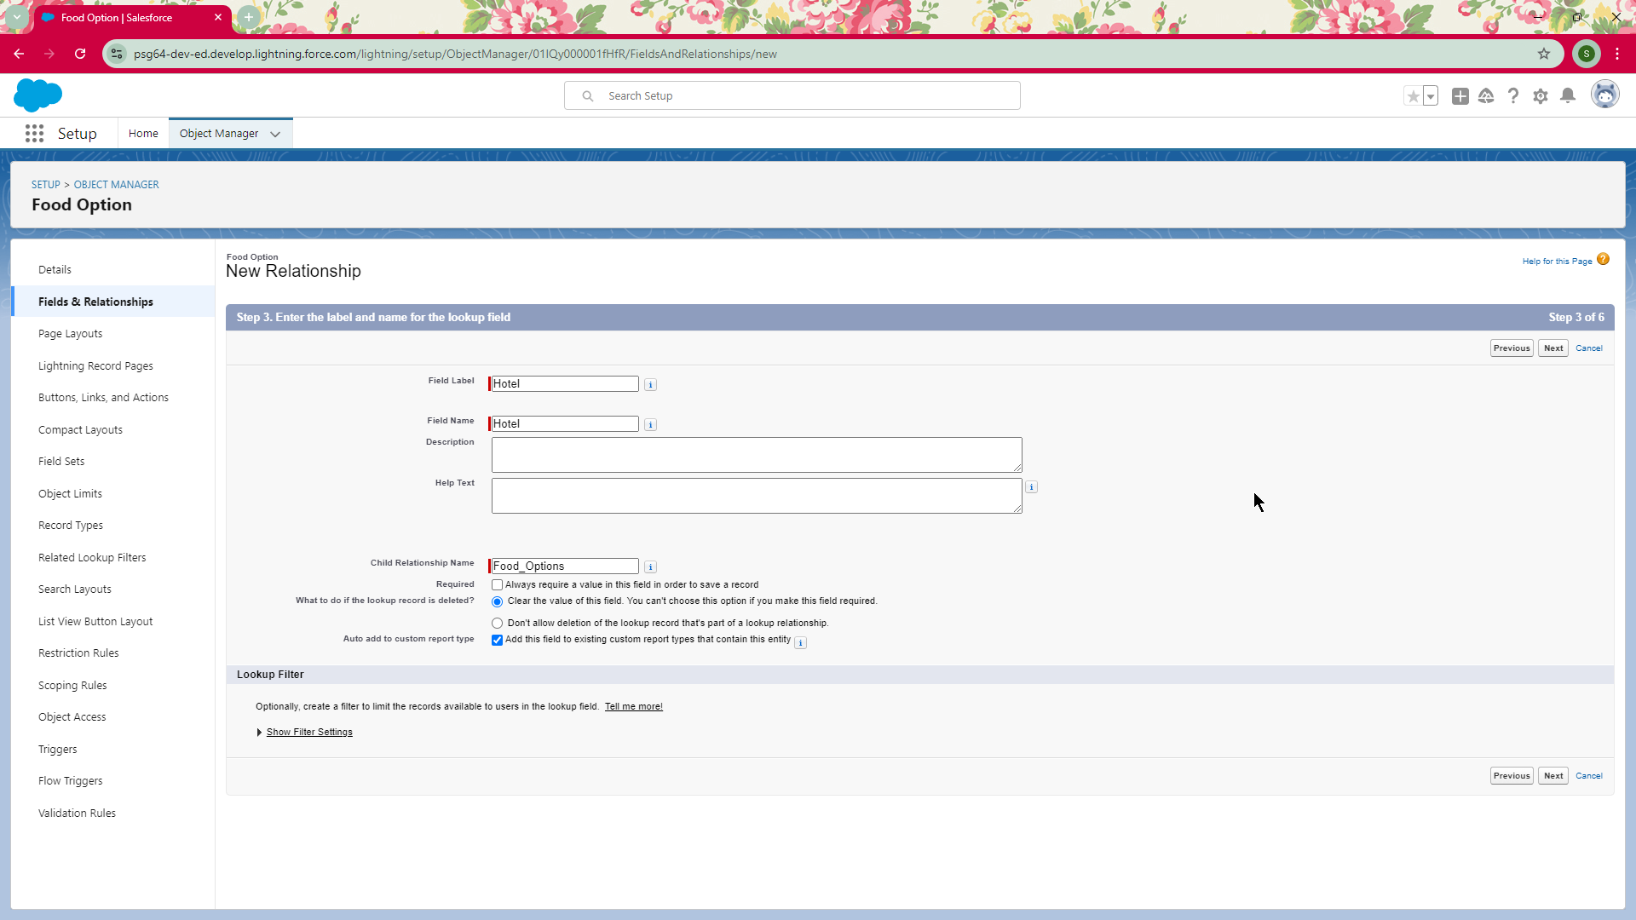

**Creating field Hotel**

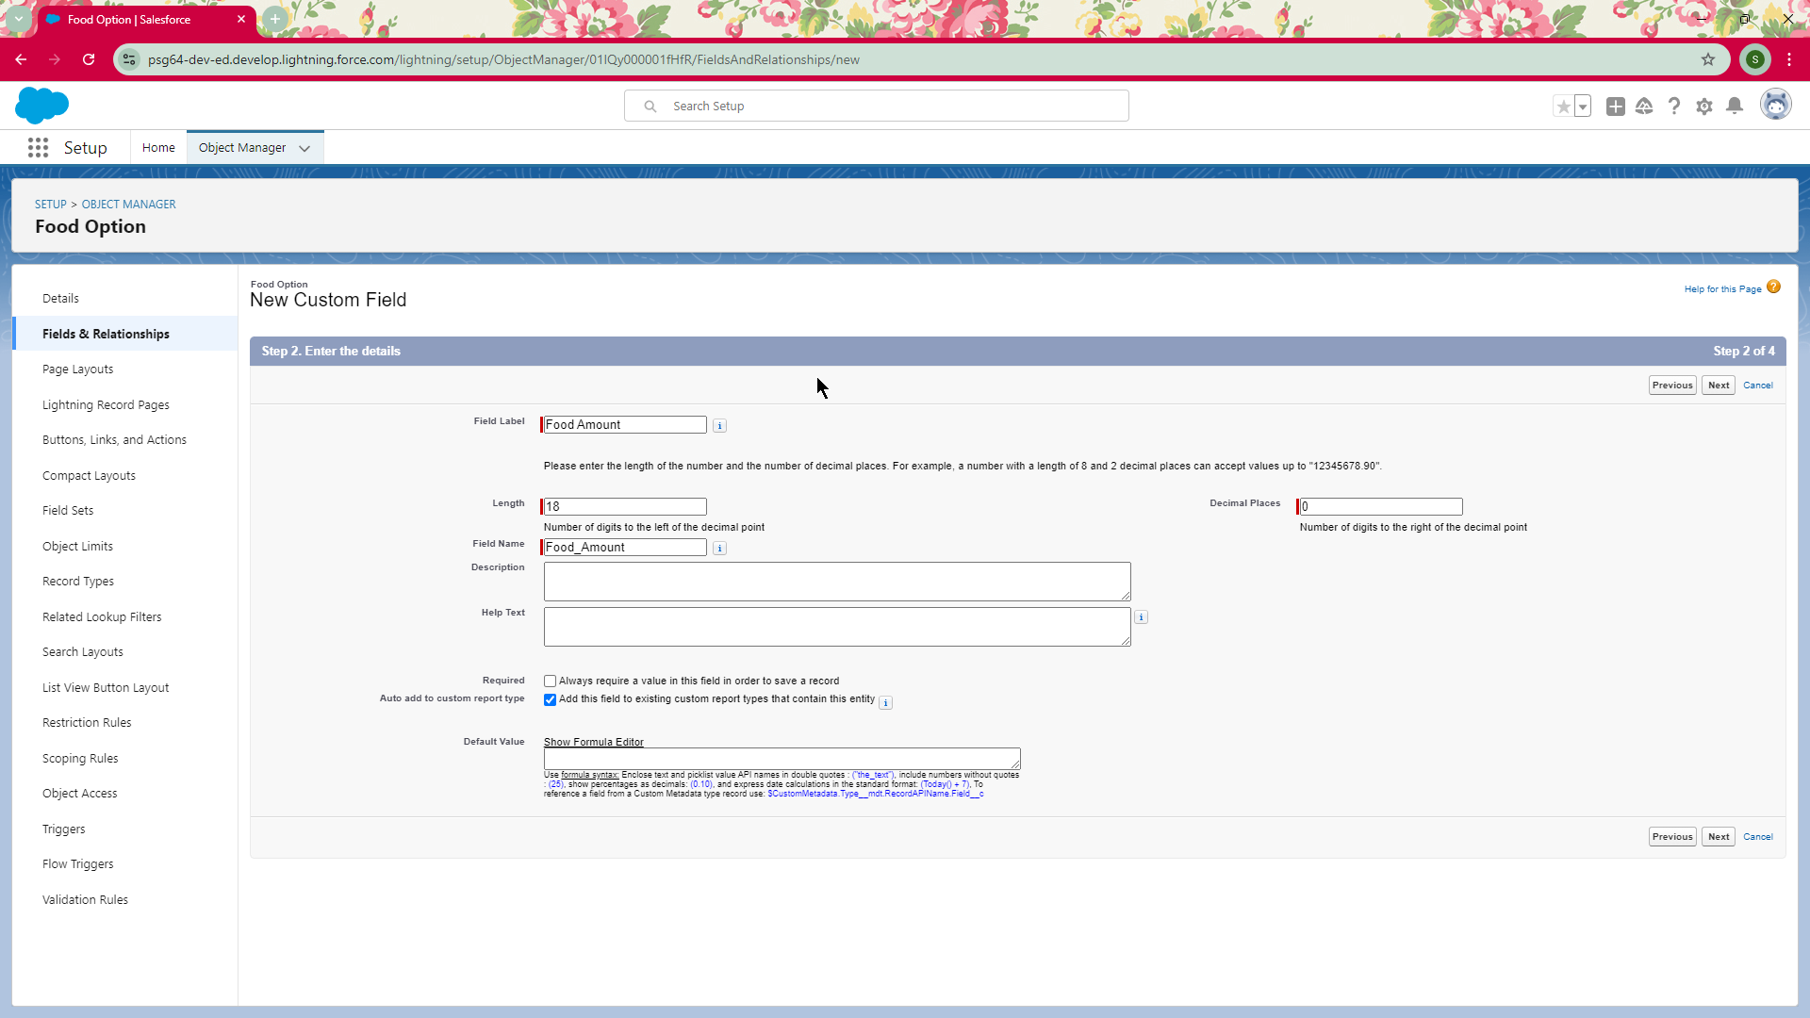

**Creating field Food Amount**

**Flight Object Fields:**

1. **Name (Text):** A name or code identifying the flight.
2. **DepartureDateTime (Date/Time):** The date and time of flight departure.

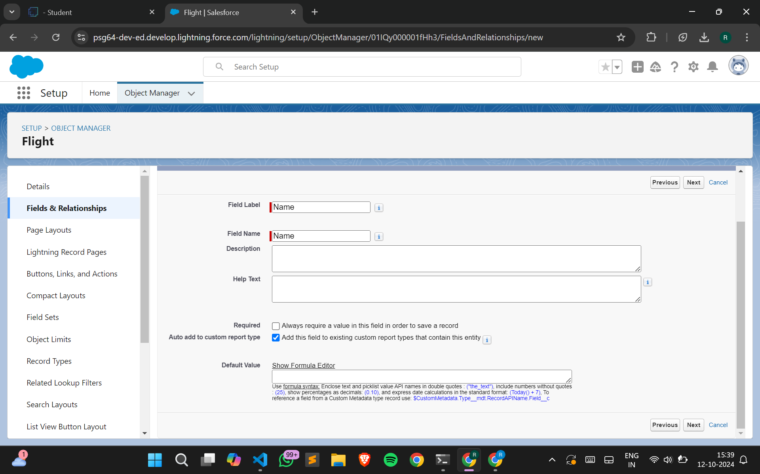

**Creating field Name**

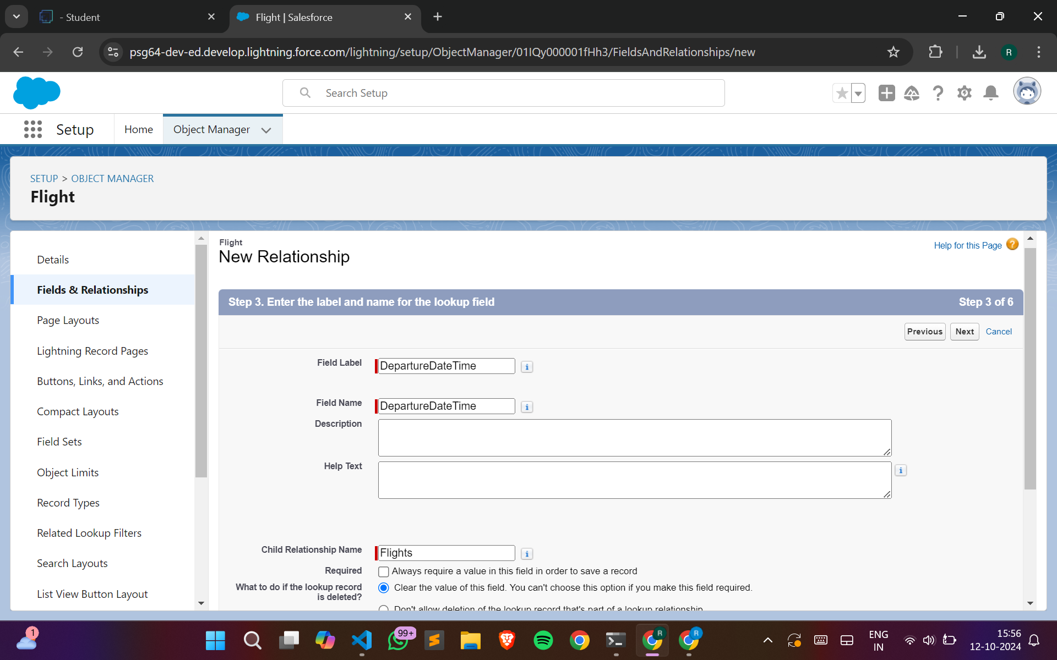

**Creating field DepartureDateTime**

**Customer Object Fields:**

1. **Customer Name (Text):** The name of the customer.
2. **Discount Amount (Formula - Currency):** A formula that calculates the discount based on customer criteria.
3. **Discount Percent (Percentage):** The percentage discount applied to the customer.

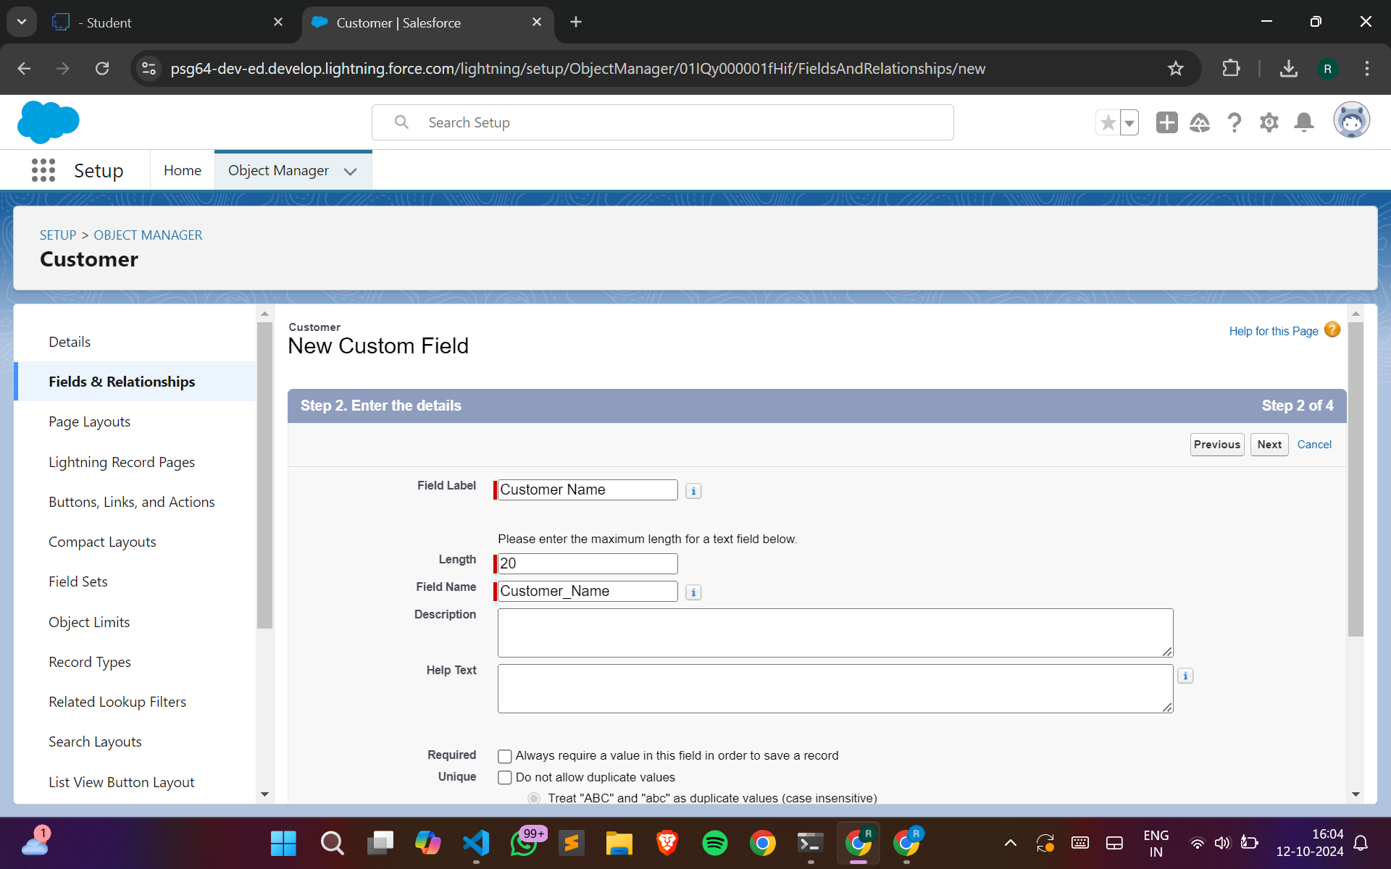

**Creating field Customer Name**

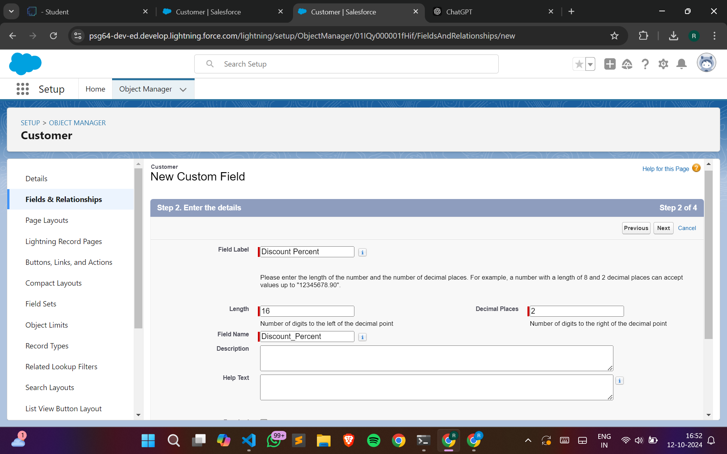

**Creating field Discount Percent**

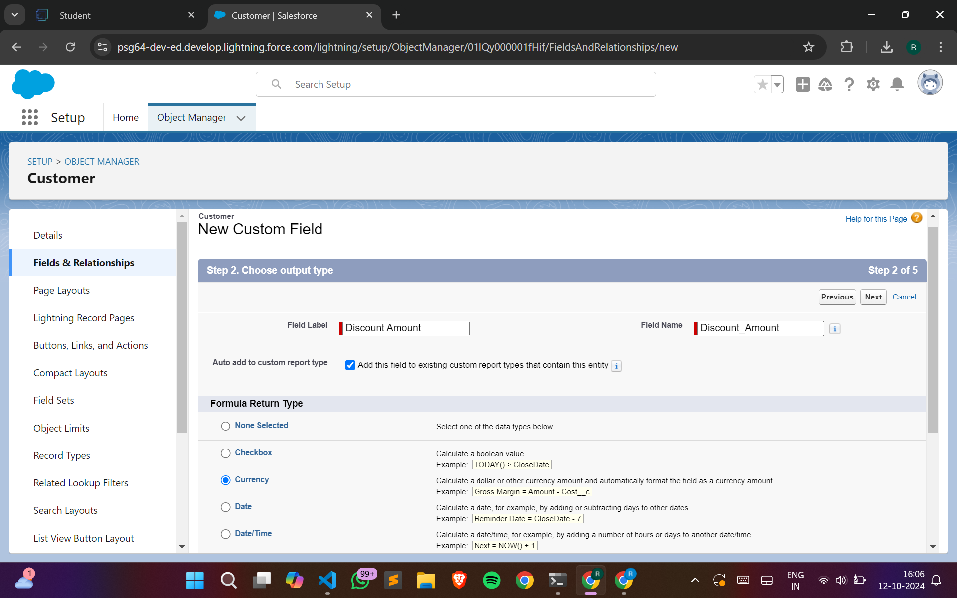

**Creating field Discount Amount**

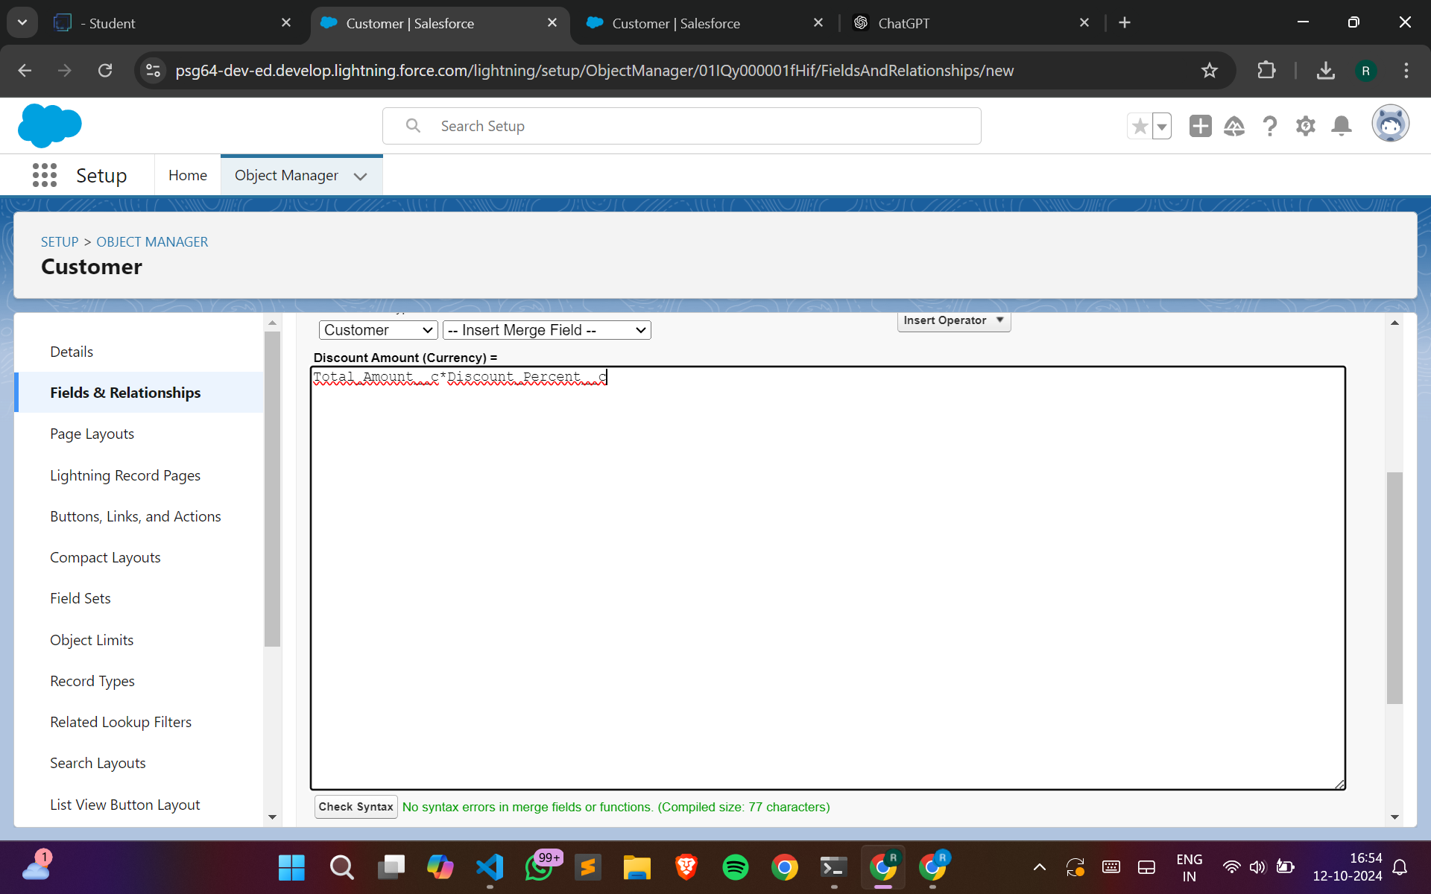

**Creating field Discount Amount**

* **Flow Testing:**

Simulated scenarios with various customer purchase amounts to confirm the correct application of discounts.

**Create flow for customer discounts:**

* **Variables:**
  + **foId (Text) -** Available for Input
  + **csId (Text) -** Available for Input
  + **discount (Number)**
* **Flow Steps:**
  + **Get Records:** Retrieve customer data based on purchase histo**ry.**
  + **Decision Element: Add decision outcomes for different discou**nt thresholds:
    - **Full Discount:** For customers with amounts greater than 3000.
    - **Partial Discount:** For customers with amounts between 1500 and 3000.
    - **No Discount:** For customers below 1500.
  + **Assignments:** Assign appropriate discounts based on decisions made above.
* **Flow Outcome:**
  + Apply the correct discount to the customer’s account based on the flow's logic.

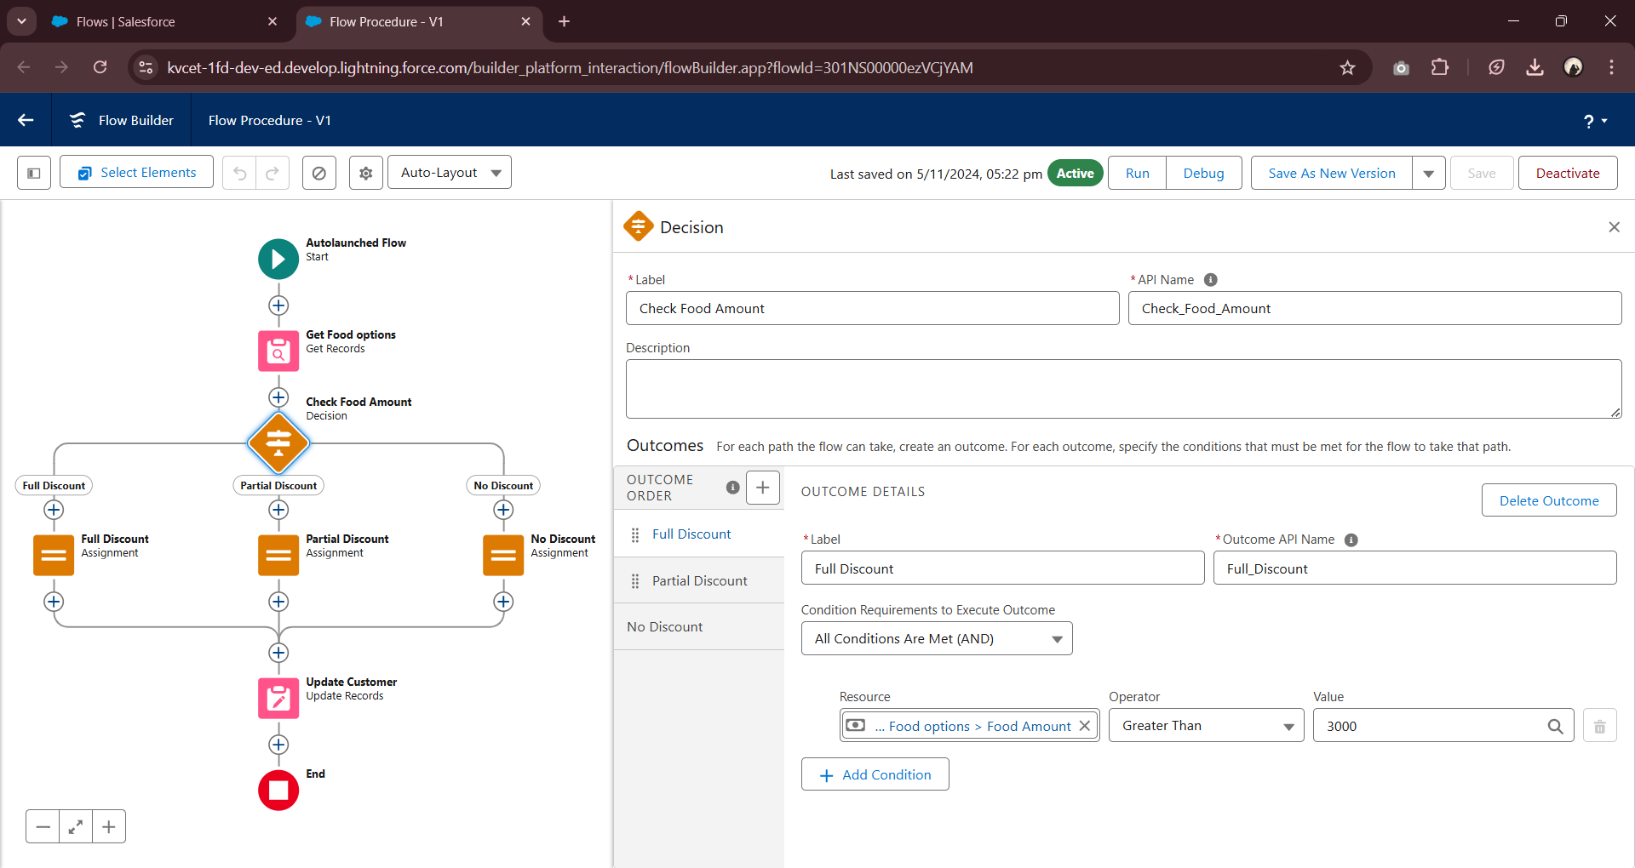

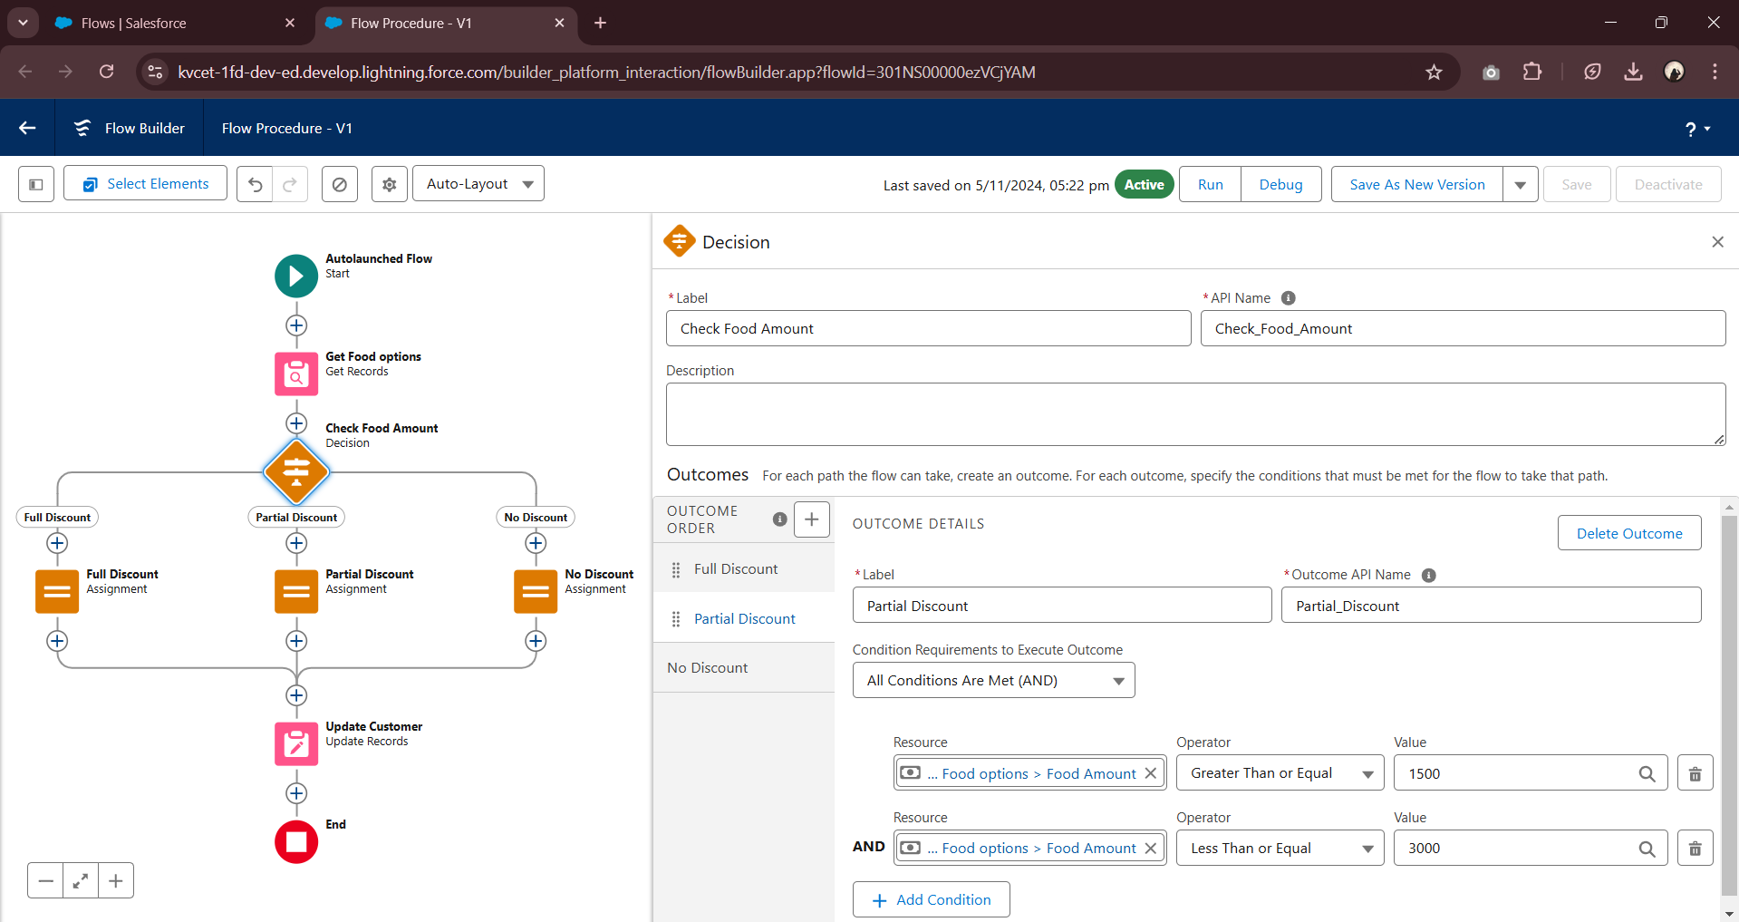

**Condition for full discount and partial discount**

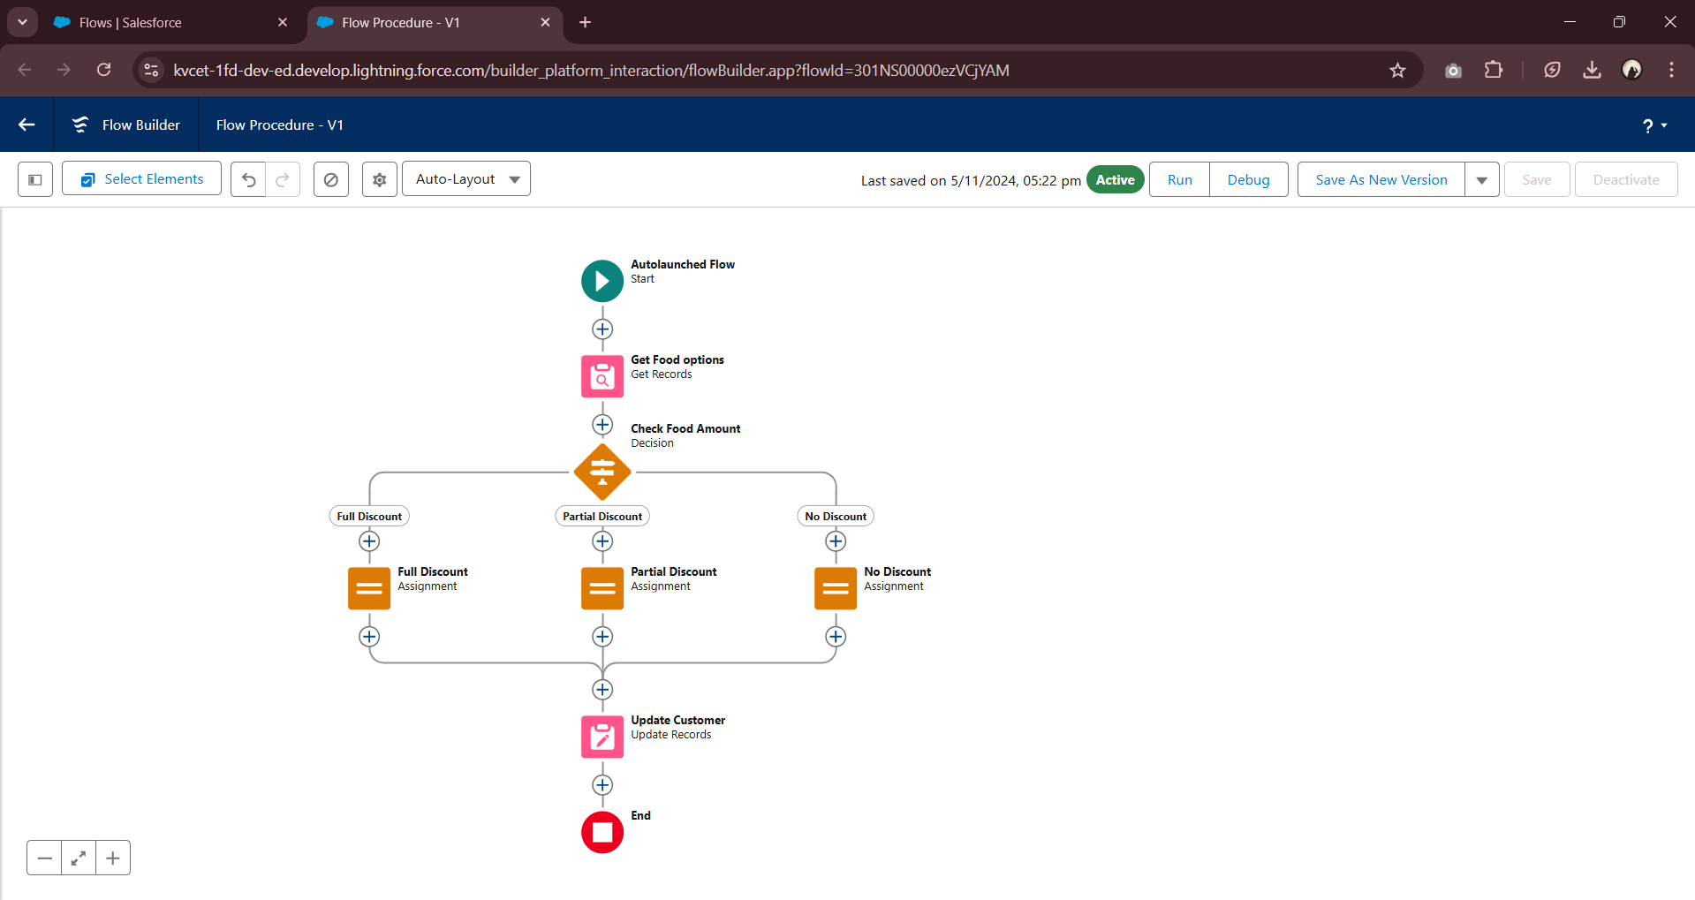

**Flow created for discount approval**

* **Apex Trigger and Handler for Updating Hotel Food Option Counts**

**Variables:**

* newFoodOptions (List of Food_Option__c) - List of new or updated food options passed to the handler.
* oldFoodOptions (List of Food_Option__c) - List of old food options (used only if required for comparisons).
* operation (TriggerOperation) - Type of trigger operation (e.g., insert, update, delete).
* hotelIdsToUpdate (Set of Id) - Set of unique Hotel IDs affected by the changes to the food options.
* hotelsToUpdate (List of Hotel__c) - List of hotel records that need to be updated.

**Apex Trigger Steps:**

1. **Trigger Setup:**

* Define a trigger on the Food_Option__c object.
* The trigger is set to run after insert, after update, and after delete to handle changes in food options.

1. **Trigger Conditions:**

* Check if the trigger is running after insert to ensure updates happen after new food options are created.

1. **Call Handler Method:**

* If the trigger is after insert, invoke updateHotelInformation from FoodOptionTriggerHandler to update hotel details based on the new food options.
* Pass trigger.new to the handler to retrieve the list of newly inserted food options.

**Apex Handler Steps (updateHotelInformation method):**

1. **Collect Hotel IDs:**

* Loop through each record in newFoodOptions.
* Add the Hotel__c (Hotel ID) from each food option to hotelIdsToUpdate to collect unique hotel IDs affected by the changes.

1. **Retrieve Hotels to Update:**

* Query the Hotel__c object for records with IDs in hotelIdsToUpdate.
* Retrieve fields Id, Name, and TotalFoodOptions__c to calculate and update the total food options for each hotel.

1. **Recalculate Total Food Options:**

* Loop through each hotel record in hotelsToUpdate.
* Run a query to count the total food options linked to each hotel using COUNT().
* Assign the result to the TotalFoodOptions__c field on the Hotel__c record.

1. **Update Hotel Records:**

* Perform an update on hotelsToUpdate to save the recalculated TotalFoodOptions__c values.

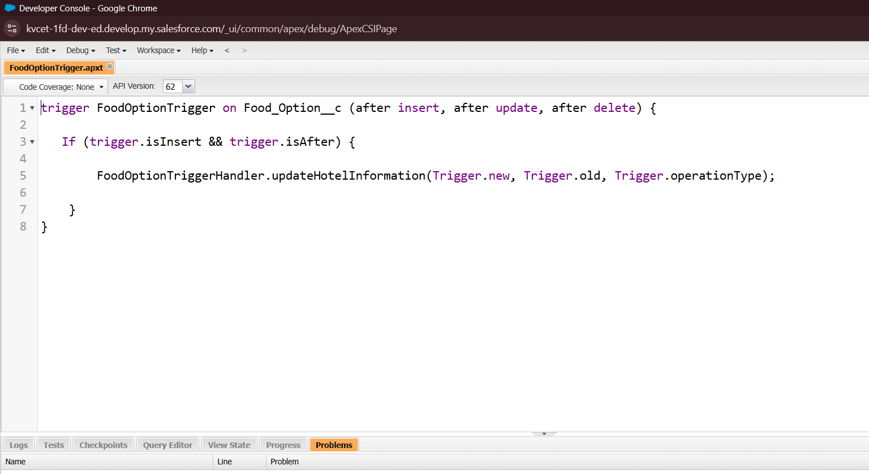

**Trigger Code (FoodOptionTrigger)**

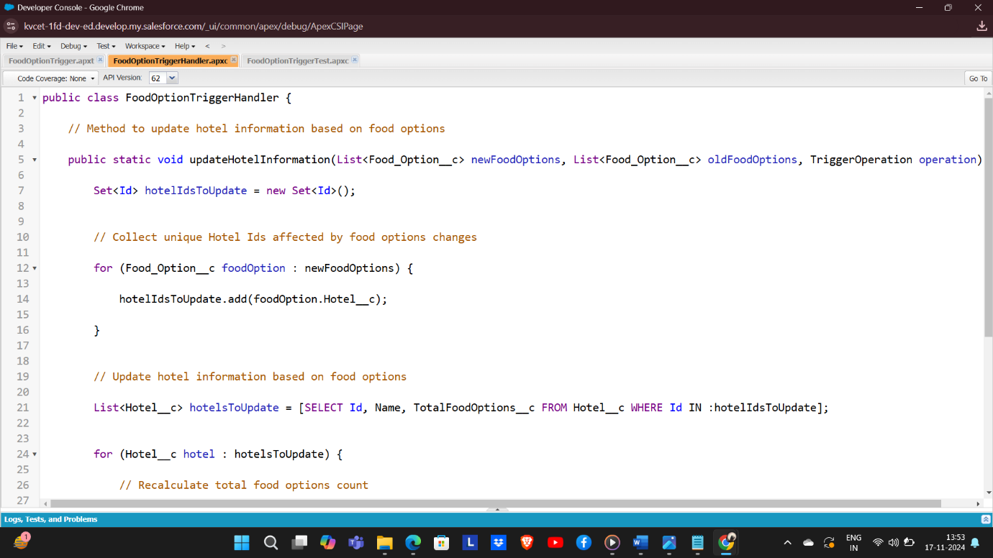

**Handler Class Code (FoodOptionTriggerHandler)**

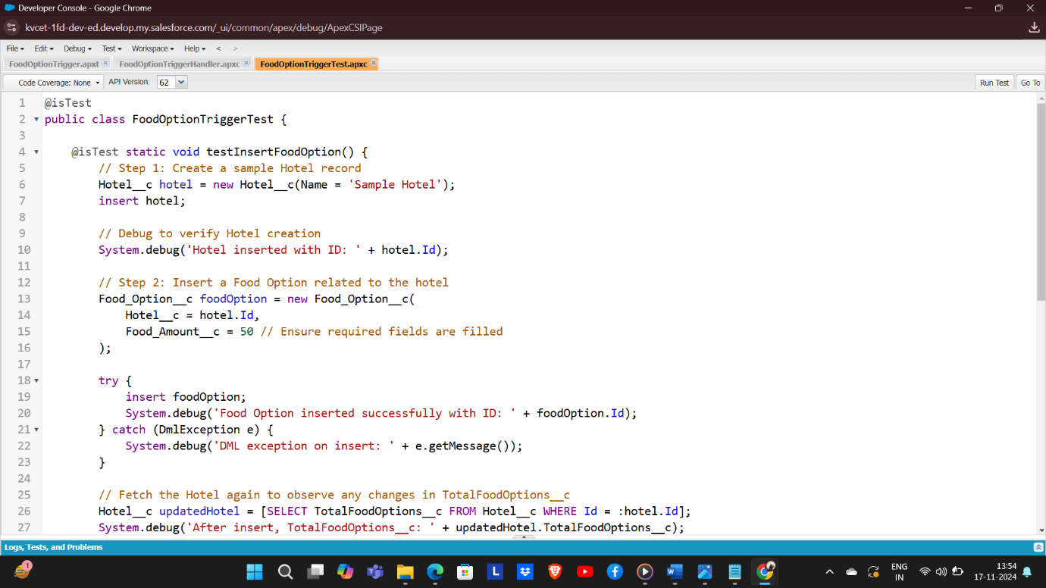

**Test Code (FoodOptionTriggerTest)**

* **Scheduled Apex Class for Automated Flight Reminder Emails**

**Variables:**

* DepartureDateTime__c (DateTime) - Custom field on the Flight__c object representing the flight's departure date and time.
* ContactEmail__c (Email) - Custom field on the Flight__c object holding the customer's contact email address for sending reminders.

**Apex Schedule Steps:**

1. **Define Apex Schedule Class:**

* Create a class named FlightReminderScheduledJob that implements the Schedulable interface, allowing it to be scheduled to run at specified times.

1. **Schedulable Interface Implementation:**

* Implement the execute method from the Schedulable interface.
* Inside execute, call the sendFlightReminders method to handle the logic for querying flights and sending reminders.

1. **Query Upcoming Flights:**

* In the sendFlightReminders method, query the Flight__c records where DepartureDateTime__c is within the next 24 hours (>= DateTime.now() and <= DateTime.now().addDays(1)).
* Retrieve fields Id, Name, DepartureDateTime__c, and ContactEmail__c.

1. **Send Reminder Email:**

* For each flight in upcomingFlights, create an email message using Messaging.SingleEmailMessage.
* Set the ToAddresses, Subject, and PlainTextBody of the email to include flight details and departure time.
* Send the email using Messaging.sendEmail().

**Anonymous Apex Code for Scheduling:**

1. **Define Cron Expression:**

* Set a cron expression to schedule the job daily at 6 AM.

1. **Schedule the Job:**

* Use System.schedule to run FlightReminderScheduledJob with the cron expression.

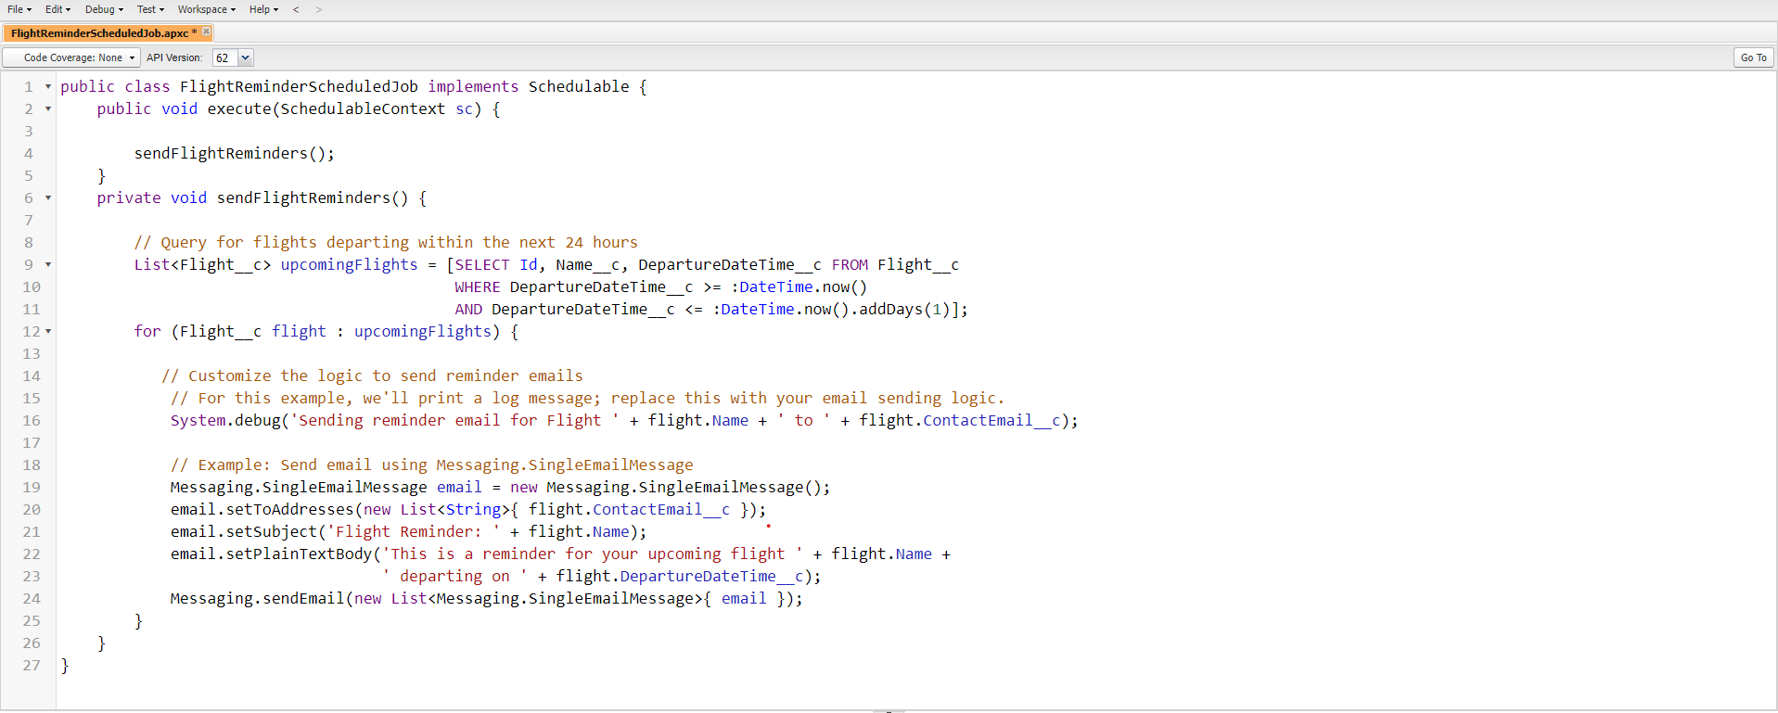

**Flight Reminder Schedule Class Code**

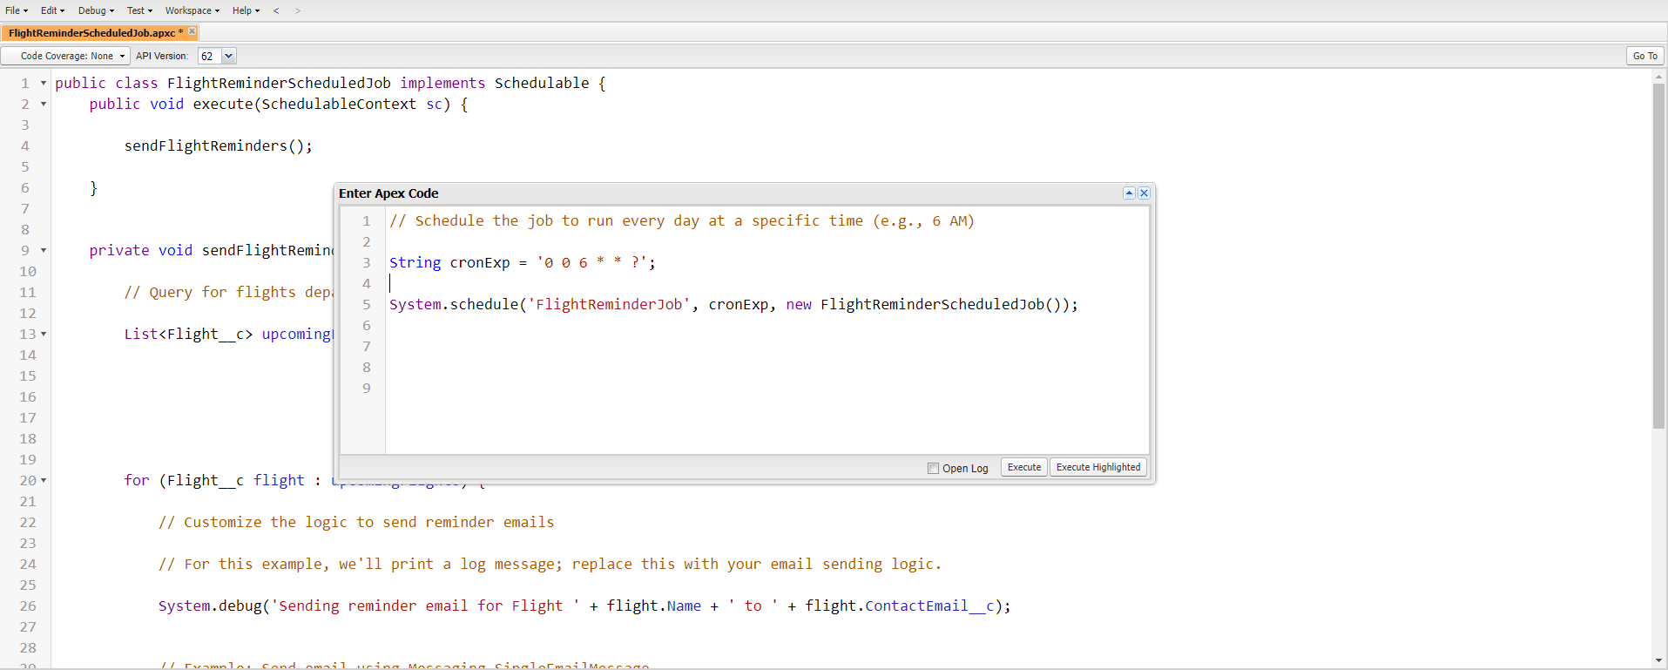

**Scheduling Job to run at Specific Time**

## 6.Key Scenarios Addressed by Salesforce in the Implementation Project

**1. Automated Hotel Data Updates:**

Trigger logic updates hotel data whenever a new food option is added, ensuring data consistency.

**2. Discount Automation:**

The discount flow reduces manual calculations, offering accurate discounts based on purchase amount.

**3. Flight Reminders for Customers:**

Scheduled job sends reminders to customers about upcoming flights, improving communication and customer satisfaction.

**7. Conclusion**

### Summary of Achievements:

The TripAdvisor E-Management Project successfully streamlined and automated various processes related to hotel management, flight bookings, food options, and customer notifications, significantly enhancing both operational workflows and the overall customer experience. Key accomplishments include:

* Optimized Operational Workflow: Implemented an integrated system for managing hotel requirements, food options, and flight bookings, ensuring seamless coordination and reducing the need for manual intervention in the TripAdvisor platform.
* Automated Customer Notifications: Developed a schedulable Apex class to send timely flight reminders to customers 24 hours before departure, improving customer service by ensuring customers are well-informed and prepared for their travels.
* Real-Time Data Synchronization: Designed and deployed Apex triggers and flows to automatically update and synchronize hotel and food option data in real-time, ensuring that customers have access to accurate and up-to-date information.
* Dynamic Discount Allocation: Created automated processes to apply personalized discounts for customers based on their purchasing behavior, offering a tailored experience that enhances customer satisfaction and loyalty.
* Improved Efficiency and Customer Experience: Leveraged Salesforce’s automation tools to reduce manual processes, allowing for quicker updates, more accurate data, and a smoother experience for customers booking hotels, flights, and food options.

This project demonstrates how Salesforce automation can effectively improve the efficiency of business operations and enhance the customer experience in the travel and hospitality industry, particularly for platforms like TripAdvisor. By integrating key processes into a single, automated system, the project helps streamline workflows, reduce manual effort, and provide a superior service to customers.

**Lessons Learned**

The project highlighted the importance of data consistency, efficient flow design, and the value of scheduled automation to improve operational efficiency.

**Future Enhancement**

Potential improvements could include additional customer feedback features, expanded discount categories, and integration with external travel and booking systems for more comprehensive travel management.